

PRESENATATION TOPIC: BASIC STATISTICAL DISTRIBUTION THEORY
GROUP ONE

COURSE TITLE: CMP 419(MODELLING AND SIMULATION
LECTURER NAME: DR Temitope Ogunbiyi

DATE:23RD JANUARY 2026

GROUP MEMBERS
- OLUWAMOROTI FAITHFUL AUL/CMP/22/109
- AJAYI OLUWAPELUMI AUL/CMP/22/013
- Okandeji Okeoghene AUL/CMP/22/059
- Akpan Nnamnso-Obong Robinson AUL/CMP/22/112
- Gideon Ayodeji AUL/CMP/22/105
- Victor Onyinyechi .D. AUL/CMP/22/088
- Abah Unekwuojo James AUL/CMP/22/090
- Akinbinu Oreoluwa AUL/CMP/22/015
- David Ezefosie AUL/CMP/22/038
- ADAH EBUBECHUKWUKA ELIJAH AUL/CMP/22/002
- Akintola Niniola
- Promise Okoli
- Fortun Busari
- Olapegba Inioluwa

TABLE OF CONTENTS

GROUP MEMBERS 2
TABLE OF CONTENTS 3
Introduction: The Role of Statistics in Modeling and Simulation 4
Descriptive Statistical Functions 7
Measures of Central Tendency 7
Measures of Dispersion (Spread) 13
Measures of Central Tendency and Dispersion 15
Importance in Simulation Studies 15
Probability Distributions: The “Engines” of Modeling and Simulation 19
Discrete Distributions (Countable Outcomes) 19
Bernoulli and Binomial Distributions 19
Poisson Distribution 20
Continuous Distributions (Uncountable Outcomes) 22
Uniform Distribution 23
Exponential Distribution 24
Normal (Gaussian) Distribution 24
Random Number Generation in Modeling and Simulation 26
Applications of Random Number Generation in Computer Science 26
Challenges, Limitations, and Future Directions in Random Number Generation 28
Pseudorandom Numbers and Their Importance 29
Inferential Statistics and Validation in Modeling and Simulation 33
Goodness-of-Fit Tests 33
Chi-Square Test 33
Kolmogorov–Smirnov (K–S) Test 34
Confidence Intervals 35
Role in Model Validation 35
Conclusion 37

Introduction: The Role of Statistics in Modeling and Simulation
Before mathematical formulas and algorithms are introduced in Modeling and Simulation (M&S), it is essential to understand why statistical functions are needed at all. Real-world systems such as banks, hospitals, transportation networks, manufacturing plants, and computer systems are not perfectly predictable. Human behavior, machine performance, environmental conditions, and operational delays all introduce uncertainty into these systems.
Statistics play a critical role in Modeling and Simulation (M&S), particularly in Department of Defense (DoD) test and evaluation, by enabling high-resolution output generation, quantifying uncertainty, and facilitating validation. It allows analysts to move beyond simple, deterministic models to complex, probabilistic models that can handle variation, identify trends, and make reliable predictions
We use statistical functions to simplify, summarize, and analyze large, complex data sets, revealing hidden patterns, trends, and relationships to support data-driven decisions, make predictions, and test hypotheses across various fields, making raw numbers understandable and actionable for better planning and understanding. They turn messy data into clear insights, whether finding the average sale (AVG), counting entries (COUNT), or identifying the highest value (MAX).
Statistics provides the tools needed to represent this uncertainty, generate realistic behavior, and interpret simulation results in a scientific and meaningful way. Without statistics, a simulation model would simply replay the same scenario every time and could not be trusted for decision-making.
Statistical functions play a foundational role in data analysis generally and are absolutely indispensable in Modeling and Simulation (M&S). Real systems—whether physical, social, or digital—produce enormous volumes of data and exhibit variability that cannot be captured using fixed or deterministic values alone. Statistics provides the mathematical framework needed to reduce complexity, uncover hidden structure, support rational decision-making, and establish confidence in simulation-based conclusions.

Statistical functions play three fundamental roles in M&S: input modeling, randomness generation, and output analysis.

1. Input Modeling: Representing Real-World Patterns
Input modeling refers to the process of analyzing real data from an existing system and fitting it to appropriate statistical distributions before feeding it into the simulation model.
In real life, events do not occur at fixed intervals. For example:
- Customers do not arrive at a bank every exactly five minutes.
- Cars reach an intersection at irregular times.
- Machines fail unpredictably.
- Service times differ from one worker to another.
To capture these variations, analysts collect historical data and use statistics to:
- calculate averages and variability,
- examine frequency patterns,
- test which probability distribution best represents the data,
- estimate parameters such as arrival rates or service rates.
Once the data is modeled statistically, the simulation can sample from these distributions instead of using constant values. This makes the model behave much more like the real system.
For instance, rather than assuming “10 customers arrive every hour,” a simulation might assume arrivals follow a Poisson distribution with an average rate of 10 per hour, allowing natural fluctuation around that value.

2. Randomness: Mimicking Uncertainty in System Behavior
Most systems studied in M&S are stochastic, meaning they involve randomness. Statistical functions allow the simulation to introduce controlled randomness that reflects real-world uncertainty.
Randomness is used to determine:
- when the next event happens,
- which customer is served next,
- how long a process takes,
- whether a machine breaks down,
- how long repairs last.
Computers cannot generate truly random numbers; instead, they use pseudorandom number generators, which produce sequences of numbers that appear random. These numbers are then transformed using statistical formulas into values that follow specific distributions such as exponential, normal, or uniform.
This controlled randomness ensures that:
- every simulation run is slightly different,
- rare events can still occur,
- long-term patterns match those seen in reality.
Without statistical randomness, a simulation would always produce identical outputs and would be useless for exploring risk, congestion, or system reliability.

3. Output Analysis: Making Sense of Simulation Results
When a simulation is executed multiple times, the results—such as waiting times, queue lengths, throughput, or system utilization—vary from run to run. These outputs are random variables, not fixed numbers.
Statistics is therefore needed to:
- summarize results using averages, medians, and standard deviations,
- measure variability and uncertainty,
- construct confidence intervals,
- compare alternative system designs,
- decide whether observed differences are meaningful or just due to chance.
For example, suppose two queue designs produce average waiting times of 8 minutes and 9 minutes. Statistics helps determine whether the 1-minute difference is significant or simply due to random fluctuations in arrivals and service times.
Through output analysis, statistics converts raw simulation data into reliable evidence that can support decisions by managers, engineers, or policymakers.

Descriptive Statistical Functions
Descriptive statistical functions are used to summarize, organize, and present the large volumes of data generated during simulation experiments. Because simulations are usually run many times under the same conditions—called replications—they produce extensive datasets consisting of waiting times, queue lengths, system utilizations, throughput values, costs, or failure counts. Examining each observation individually is impractical.
Descriptive statistics reduce this complexity by expressing the overall behavior of the system through a few carefully chosen numerical measures. These measures fall into two main categories: measures of central tendency, which describe what is typical or average, and measures of dispersion, which describe how much the results fluctuate around that typical value.

Measures of Central Tendency

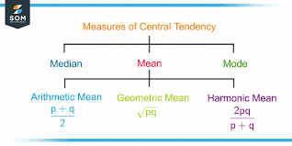
Figure 1:Measure of central Tendency
In statistics, the central tendency is the descriptive summary of a data set. Through the single value from the dataset, it reflects the center of the data distribution. Moreover, it does not provide information regarding individual data from the dataset, where it gives a summary of the dataset. Generally, the central tendency of a dataset can be defined using some of the measures in statistics.
The central tendency is stated as the statistical measure that represents the single value of the entire distribution or a dataset. It aims to provide an accurate description of the entire data in the distribution.
Measures of central tendency indicate the “center” of a dataset—the value around which simulation results tend to cluster. In M&S, they are essential for reporting system performance in a concise form.
The central tendency of the dataset can be found out using the three important measures namely mean, median and mode.

Mean ( $\overset{ˉ}{x}$)
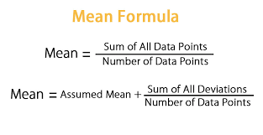
Figure 2:Mean
The mean is the arithmetic average of all observed values and is calculated by summing the outputs from all simulation runs and dividing by the number of observations. It is the most commonly reported statistic in simulation studies.
It represents the average value of the dataset. It can be calculated as the sum of all the values in the dataset divided by the number of values. In general, it is considered as the arithmetic mean. Some other measures of mean used to find the central tendency are as follows:
- Geometric Mean
- Harmonic Mean
- Weighted Mean
It is observed that if all the values in the dataset are the same, then all geometric, arithmetic and harmonic mean values are the same. If there is variability in the data, then the mean value differs. Calculating the mean value is completely easy. The formula to calculate the mean value is given by:
The histogram given below shows that the mean value of symmetric continuous data and the skewed continuous data.

In practice, the mean might represent:
- the average waiting time of customers in a queue,
- the average number of jobs in a system,
- the average daily production level,
- the average utilization of a machine.
Because it incorporates every data point, the mean provides a good overall picture of system behavior. However, it can be influenced by extreme values—such as rare but very long delays—so it is often interpreted alongside other measures.
$$x=\frac{x_{1}+x_{2}+x_{3}+…x_{n}}{n}$$

Median
The median is the middle value when all observations are arranged in ascending order. Half of the results lie above it and half below.
In simulation analysis, the median is particularly useful when the output distribution is skewed or contains outliers. For example, most customers in a service system may wait only a few minutes, while a small number experience extremely long waits during peak periods. In such a case, the mean might appear large, whereas the median reflects what a “typical” customer experience.
Thus, reporting both mean and median provides a more complete understanding of system performance.
Median is the middle value of the dataset in which the dataset is arranged in the ascending order or in descending order. When the dataset contains an even number of values, then the median value of the dataset can be found by taking the mean of the middle two values.
Consider the given dataset with the odd number of observations arranged in descending order – 23, 21, 18, 16, 15, 13, 12, 10, 9, 7, 6, 5, and 2
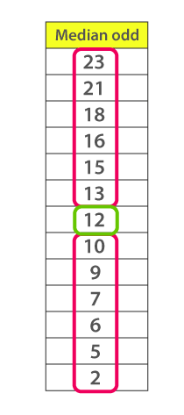
Figure 3:Median of a given set of numbers
Here 12 is the middle or median number that has 6 values above it and 6 values below it.
Now, consider another example with an even number of observations that are arranged in descending order – 40, 38, 35, 33, 32, 30, 29, 27, 26, 24, 23, 22, 19, and 17
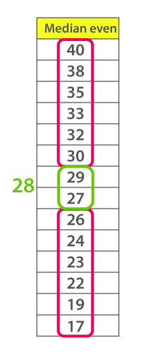
Figure 4:Median of a given set of numbers
When you look at the given dataset, the two middle values obtained are 27 and 29.
Now, find out the mean value for these two numbers.
i.e., $\frac{(27+29)}{2}$
Therefore, the median for the given data distribution is 28.

Mode
The mode is the value that occurs most frequently. It is especially relevant in discrete simulations, where outputs take countable values.
Examples include:
- the most common number of customers in a queue,
- the typical number of breakdowns per day,
- the most frequent number of packets waiting in a buffer.
Although the mode is less commonly used than the mean in continuous-output simulations, it can be helpful for identifying the most probable system state.
The mode represents the frequently occurring value in the dataset. Sometimes the dataset may contain multiple modes and, in some cases, it does not contain any mode at all.
Consider the given dataset 5, 4, 2, 3, 2, 1, 5, 4, 5
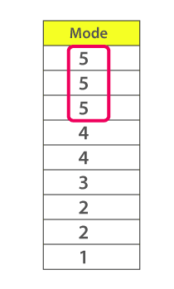
Figure 5:Mode of a given set of numbers
Since the mode represents the most common value. Hence, the most frequently repeated value in the given dataset is 5.

Measures of Dispersion (Spread)
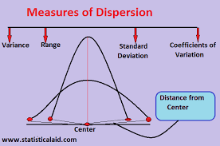
Figure 6:Measure of Dispersion
While central tendency tells us what is typical, dispersion measures reveal how much variability exists in the results. Two systems may have the same average waiting time but very different levels of reliability or consistency. Dispersion measures capture this uncertainty and are therefore critical in M&S.

Variance ( $s^{2}$)4
Variance measures the average squared deviation of each observation from the mean. It indicates how widely the simulation outputs are spread.
A large variance suggests:
- highly fluctuating waiting times,
- unpredictable system performance,
- occasional extreme conditions.
In contrast, a small variance implies that the system behaves more consistently from run to run. Although variance is mathematically useful, its units are squared (for example, minutes²), which can make interpretation less intuitive.
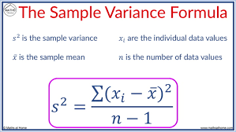
Figure 7:Variance

Standard Deviation ( $s$)
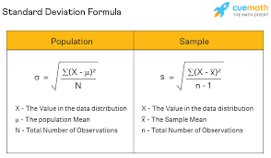
Figure 8:Standard deviation
The standard deviation is the square root of variance and is expressed in the same units as the original data. This makes it much easier to interpret.
In a queueing simulation, for instance, if the average waiting time is 10 minutes with a standard deviation of 2 minutes, analysts understand that most observations fall within a few minutes of the mean. Standard deviation is therefore one of the most widely reported measures of uncertainty in simulation output analysis.

Coefficient of Variation (CV)
The coefficient of variation is a relative measure of dispersion defined as:
$$CV=\frac{s}{\overset{ˉ}{x}}$$
It expresses variability as a proportion of the mean and is especially useful for comparing different simulation models or scenarios.
For example, two systems might have:
- System A: mean wait = 5 minutes, standard deviation = 1 minute (CV = 0.2)
- System B: mean wait = 20 minutes, standard deviation = 3 minutes (CV = 0.15)
Although System B has a larger standard deviation, System A is actually more variable relative to its average performance. The coefficient of variation makes such comparisons fair and meaningful.

Measures of Central Tendency and Dispersion
The central tendency measure is defined as the number used to represent the center or middle of a set of data values. The three commonly used measures of central tendency are the mean, median, and mode.
A statistic that tells us how the data values are dispersed or spread out is called the measure of dispersion. A simple measure of dispersion is the range. The range is equivalent to the difference between the highest and least data values. Another measure of dispersion is the standard deviation, representing the expected difference (or deviation) among a data value and the mean.

Importance in Simulation Studies
Together, measures of central tendency and dispersion allow analysts to:
- Summarize large simulation datasets
  - Reduce thousands of simulation observations into a few meaningful statistics such as the mean, median, variance, and standard deviation.
  - Make results easier to interpret and communicate to managers, engineers, and decision-makers.
- Describe typical system behavior
  - Identify what normally happens in the system under steady operating conditions.
  - Distinguish between consistent performance and systems that frequently experience extreme outcomes.
  - Reveal hidden operational problems that may not be obvious from averages alone.
- Quantify uncertainty and risk
  - Measure how much randomness affects system outputs.
  - Estimate the likelihood of undesirable events such as long delays, congestion, or system failures.
  - Support risk-aware planning in safety-critical environments like healthcare, transportation, and manufacturing.
- Compare alternative designs
  - Evaluate different system configurations, policies, or resource levels.
  - Compare both average performance and variability across competing scenarios.
  - Use relative measures such as the coefficient of variation to ensure fair comparisons between systems of different scales.
- Judge system stability and reliability
  - Assess whether the system behaves predictably over repeated simulation runs.
  - Detect unstable behavior, excessive fluctuations, or sensitivity to changes in input parameters.
  - Support long-term improvement decisions by identifying the need for redesign or additional capacity.
In Modeling and Simulation, these descriptive statistical functions form the first layer of output analysis. They provide the numerical foundation upon which further inferential methods—such as confidence intervals and hypothesis testing—are built.

Why Probability Distributions Matter in Simulation
Choosing the appropriate probability distribution is fundamental to building credible and reliable simulation models. Because simulation systems are driven by uncertainty and randomness, incorrect assumptions about input behavior can distort results, misguide engineering decisions, and lead to unsafe operational policies.
Mastery of probability distributions enables students to:
- Model real-world uncertainty accurately
  - Represent randomness inherent in physical, human, or technological systems.
  - Capture variability in arrival times, service durations, machine failures, and repair processes.
  - Reflect realistic operating environments rather than oversimplified deterministic behavior.
- Generate realistic system inputs
  - Use historical or observed data to select distributions that resemble actual system behavior.
  - Ensure that simulated inputs such as demand levels, processing times, and breakdown events follow plausible patterns.
  - Prevent unrealistic system performance that may arise from arbitrary or poorly chosen distributions.
- Analyze performance under varying conditions
  - Study how systems behave during peak loads, disruptions, or extreme situations.
  - Conduct “what-if” analyses by modifying distribution parameters such as means or variances.
  - Identify operational limits and bottlenecks that emerge under stress scenarios.
- Evaluate risk and rare events
  - Estimate the probability of low-frequency but high-impact outcomes, such as major system failures or severe congestion.
  - Support safety-critical decision-making in sectors like aviation, healthcare, defense, and transportation.
  - Quantify worst-case scenarios and tail behavior that may not appear in average-based analyses.
- Design robust systems
  - Develop systems that perform reliably across a wide range of uncertain conditions.
  - Test alternative designs or control policies before real-world implementation.
  - Support resilient engineering by identifying configurations that minimize vulnerability to random disruptions.

Probability Distributions: The “Engines” of Modeling and Simulation
In Modeling and Simulation (M&S), probability distributions are often described as the “engines” of a simulation model because they drive the random behavior of system components. They determine when events occur, how long processes take, how many entities arrive within a given period, and whether particular outcomes happen at all. Without probability distributions, a simulation would be purely deterministic and incapable of representing the uncertainty that exists in real-world systems.
Understanding probability distributions is especially critical because they form the mathematical foundation for input modeling, random event generation, and system variability. By selecting appropriate distributions, analysts can realistically represent phenomena such as customer arrivals, machine failures, service times, traffic flow, and network congestion.
Probability distributions used in M&S are commonly grouped into discrete distributions, which deal with countable outcomes, and continuous distributions, which describe quantities that can take any real value within a range.

Discrete Distributions (Countable Outcomes)
A discrete distribution is a statistical distribution that shows the probabilities of discrete (countable) outcomes, such as 1, 2, 3...
Statistical distributions can be either discrete or continuous. A continuous distribution is built from outcomes that fall in a continuum, such as all numbers greater than 0 (which includes
numbers whose decimals continue indefinitely,
Such as 3.14159265 ...). Overall, the concepts of discrete and continuous probability distributions and the random variables they describe are the underpinnings of probability
theory and statistical analysis.
Discrete distributions apply when the random variable can take only integer values—such as 0, 1, 2, 3, and so on. In simulation, they are frequently used to model counts of events.

Bernoulli and Binomial Distributions
Bernoulli's Trials are experiments in probability where only two possible outcomes are possible: Success or Failure, True or False, Yes or No. Due to the fact of two possible outcomes, it is also called the Binomial Trial.
The Bernoulli distribution models the simplest type of random experiment: one trial with two possible outcomes, typically labeled success or failure. In simulation, this might represent:
- whether a machine functions or breaks during a shift,
- whether a packet is transmitted successfully or lost,
- whether a customer completes service or abandons a queue.
The Binomial distribution extends this idea to multiple independent trials, each with the same probability of success. It describes the probability of achieving a specific number of successes in a fixed number of independent Bernoulli trials. It answers questions such as how many successes occur in a fixed number of attempts.
For example:
- out of 100 manufactured items, how many are defective?
- how many servers fail during a day?
- how many users successfully connect during peak hours?
These distributions are useful whenever outcomes are binary and repeated under similar conditions.
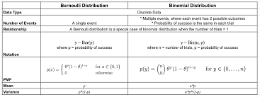
Figure 9:Bernoulli and Binomial Distributions table

Poisson Distribution
Poisson Distribution is a discrete probability distribution that expresses the probability of a given number of events occurring in a fixed interval of time if these events occur with a known constant mean rate and independently of the time since the last event.^{[1]} It can also be used for the number of events in other types of intervals than time, and in dimension greater than 1 (e.g., number of events in a given area or volume). The Poisson distribution is named after French mathematician Siméon Denis Poisson. It plays an important role for discrete-stable distributions.
Under a Poisson distribution with the expectation of λ events in a given interval, the probability of k events in the same interval is:^{[2]: 60}
$\frac{λ^{k}e^{−λ}}{k!}.$
For instance, consider a call center which receives an average of λ = 3 calls per minute at all times of day. If the number of calls received in any two given disjoint time intervals is independent, then the number k of calls received during any minute has a Poisson probability distribution. Receiving k = 1 to 4 calls then have a probability of about 0.77, while receiving 0 or at least 5 calls have a probability of about 0.23.
A classic example used to motivate the Poisson distribution is the number of radioactive decay events during a fixed observation period.^{[3]}

The Poisson distribution is one of the most important distributions in Modeling and Simulation. It models the number of events that occur within a fixed time interval or spatial region, assuming that:
- events occur independently,
- the average rate is constant,
- two events cannot occur at exactly the same instant.
In simulation, the Poisson distribution is widely used to represent:
- customer arrivals at a service facility,
- phone calls reaching a call center,
- packets arriving at a router per second,
- failures in a mechanical system,
- accidents at a junction.
If historical data indicates that an average of 20 packets arrive per second at a router, a Poisson distribution with mean 20 can be used to generate realistic fluctuations around that average.
Because many queueing models rely on Poisson arrivals, this distribution plays a central role in telecommunications, transportation systems, and service operations.
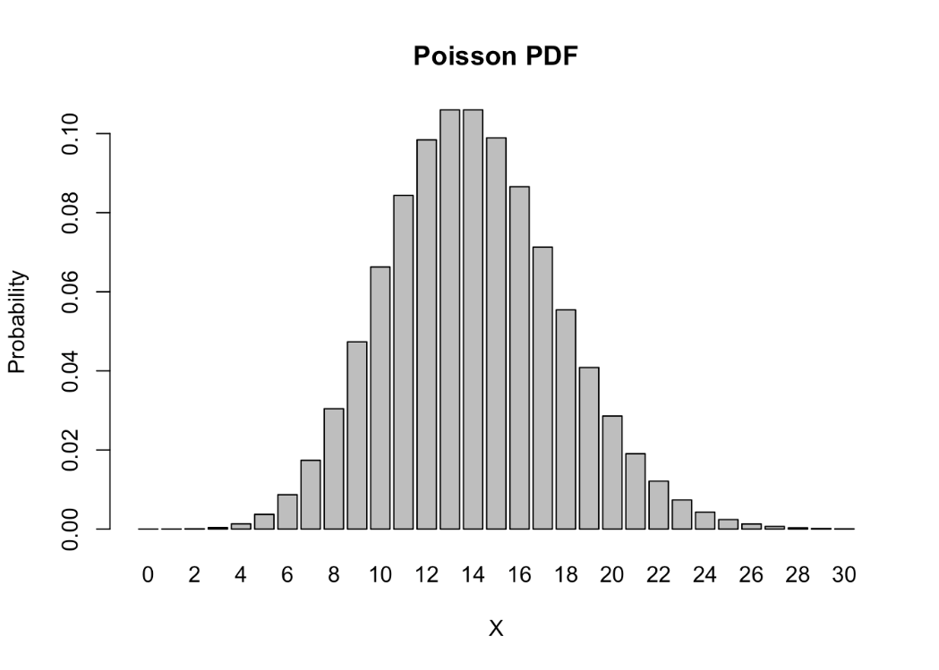
Figure 10:Poisson Distribution

Continuous Distributions (Uncountable Outcomes)
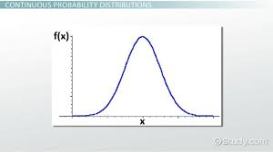
Continuous probability distributions are essential in modeling random variables that can take on any value within a range. They use probability density functions to describe the likelihood of specific values and cumulative distribution functions to calculate probabilities over intervals
The following are some properties of Continuous probability distributions
- Continuous probability distributions model random variables that can take on any value within a specified range or interval
- Unlike discrete distributions, continuous distributions have an uncountable number of possible values and are represented by probability density functions

Continuous distributions are used when a random variable can take any real value within an interval. These are common for modeling time durations, physical measurements, and system errors.

Uniform Distribution
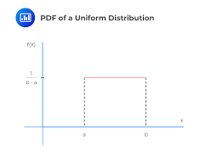
Figure 11:Uniform Distribution
In a Uniform distribution, every value within a specified interval $\left[a , b\right]$has exactly the same probability of occurring. There is no preference for one value over another.
In simulation, the Uniform distribution is fundamental because most random number generators in computers initially produce values between 0 and 1—called Uniform (0,1). These numbers are then mathematically transformed into other distributions such as exponential, normal, or Poisson.
Uniform distributions may also directly model systems where outcomes are genuinely equally likely, such as:
- selecting a random location in a region,
- choosing a random direction,
- random inspection times within a fixed window.

Exponential Distribution
The Exponential distribution is commonly used to model inter-arrival times—the time between successive events—especially when arrivals follow a Poisson process.
For example, it can represent:
- the time between customers entering a bank,
- the time between phone calls at a help desk,
- the time between packets arriving at a network router,
- the operating time of a component before failure.
A distinctive feature of the exponential distribution is its memoryless property, meaning the probability that an event will occur in the next few minutes does not depend on how long you have already waited. This makes it suitable for modeling random failures or arrivals in systems where past history does not influence future occurrence.

Normal (Gaussian) Distribution
The Normal distribution, often called the Gaussian distribution, has a symmetrical, bell-shaped curve centered around its mean. Many natural and engineered processes cluster around an average value with random fluctuations above and below it.
In M&S, the Normal distribution is used for:
- measurement errors,
- manufacturing tolerances,
- physical properties of materials,
- processing times influenced by many small random factors,
- environmental noise in sensor systems.
A Gaussian distribution, also known as a normal distribution, is a continuous probability distribution characterized by its bell-shaped curve. It is defined by two parameters:
- μ (mu): The mean or expected value of the distribution
- σ (sigma): The standard deviation, which measures the spread of the distribution
The probability density function (PDF) of a Gaussian distribution is given by:

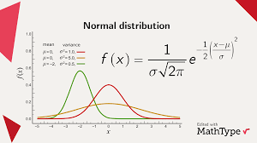
Figure 12:Normal (Gaussian) Distribution
Where:
- x is the variable
- e is Euler's number (approximately 2.71828)
- π (pi) is the mathematical constant pi (approximately 3.14159)

Because extreme values are relatively rare and most observations lie near the mean, the normal distribution is appropriate for systems that exhibit moderate, symmetric variability.

Random Number Generation in Modeling and Simulation
Random number generation is a fundamental component of Modeling and Simulation (M&S). Without randomness—or what is often called “noise”—a simulation would produce the same results every time it is run, making it incapable of representing the uncertainty and variability that characterize real-world systems. Events such as customer arrivals, machine breakdowns, service durations, network traffic, and human decisions are inherently unpredictable. Random number generators provide the mechanism for introducing this uncertainty into simulation models in a controlled and repeatable way.
It is a fundamental technique widely used in computer science for applications such as simulations, cryptography, machine learning, and hardware security. 1 2 In simulation contexts, random values are typically generated with predefined statistical distributions. This process often begins with producing a sequence of random numbers uniformly distributed between 0 and 1, followed by random-variate generation to transform these values into the desired distribution.
The value of a uniform (0, 1) random variable is called a random number. Whereas in the past, mechanical devices have often been used to generate random numbers, today we commonly use random number generators to generate a sequence of pseudo random numbers. Such random number generators start with an initial value xo, called the seed, and then recursively determine values by first specifying positive integers a, c, and m and then letting
$$x_{n+1}=\left(ax_{n}+c\right)\text{ modulo }m,n≥0$$
where the preceding means that x_{n+1} is the remainder obtained when ax_{n} + c is divided by m. Thus each x_{n} is one of the values 0, 1,…, m – 1, and the quantity x_{n}/m is taken as the random number. It can be shown that for suitable choices of a, c, and m, the preceding gives rise to a sequence of numbers that looks as if it was generated by observing the values of independent uniform (0, 1) random variables. For this reason we call the numbers x_{n}/m, n ≥ 1,pseudo random numbers.

Applications of Random Number Generation in Computer Science
Simulation and Modeling
Random number generation is foundational in simulation, where sequences of uniformly distributed random numbers between 0 and 1 are transformed into values with desired statistical distributions for modeling purposes. 1 Discrete-event simulation models, such as those used for computer networks, rely on random number generation to characterize system workloads via probability distributions, supporting both trace-driven and stochastic simulation approaches. Stochastic simulations use these random values as inputs to the simulation model.
Cryptography and Security
Random number generation is essential for cryptographic applications, including generating session keys, digital signatures, masks, and challenges in authentication protocols. 2 The unpredictability of random numbers is critical, as predictable RNGs can lead to security breaches if their internal state or seed is known. 7 TRNGs use unpredictable physical means, while PRNGs rely on deterministic algorithms; attacks against PRNGs highlight the need for stronger TRNGs in security-sensitive contexts. Hardware-based security enables TRNGs to be used for robust hash-based message authentication code (HMAC) systems with counters to protect against replay attacks and message tampering. 11
Machine Learning and Data Science
Random number generation is used for random initialization of centroids in clustering algorithms such as k-means, where setting a specific seed ensures repeatable results. 12 In ray tracing routines, random number generation initializes ray locations for antialiasing and randomizes the direction of reflected rays, with specific routines for host and CUDA implementations. 13 Efficient libraries like cuRAND generate high-quality random numbers on GPUs for swarm intelligence algorithms. 14
Gaming and Procedural Content Generation
In programming environments such as Python and MATLAB, random number generation functions produce values from uniform distributions, with repeated invocations yielding different outputs, supporting gaming and procedural content generation. 4
Hardware and Embedded Systems
TRNGs use unpredictable physical means to generate numbers, which is crucial for cryptographic applications. 2 Physically Unclonable Functions have been increasingly proposed as TRNGs in cryptographic protocols and security architectures, exploiting intrinsic and random hardware variations to generate unique and unpredictable responses. PUFs are also used to generate random number responses for given challenges, protecting chips or circuits from attackers. 15

Challenges, Limitations, and Future Directions in Random Number Generation
PRNGs, being deterministic algorithms, have predictability concerns in cryptographic applications, as an adversary who knows the seed can generate and predict the entire random number stream. Therefore, seed uniqueness and unpredictability are essential for security. 7 While PRNG reproducibility is valuable for simulation repeatability, it is undesirable in security-sensitive contexts. 1 Rigorous testing and validation of RNGs are mandatory, as weak random number generation and non-independent seeds can significantly impact simulation and cryptographic results, necessitating the use of trustworthy and widely known generators.
TRNGs rely on physical entropy sources, but their reliability can be affected by environmental and process variations such as power supply fluctuations, temperature deviations, and clock frequency changes. These factors can introduce bias and predictability, requiring cryptographic hash functions, von Neumann correctors, and stream ciphers to manipulate raw output and ensure statistical randomness and uniformity. 6 Additional tuners and processing blocks may be employed to control TRNG quality and throughput, with operating conditions being key factors for generating truly random numbers.
Performance trade-offs are evident in RNG, as execution time efficiency is critical when running extensive simulations, especially in high-throughput or resource-constrained environments. 16 Program performance can be significantly improved when random number generation is handled by the graphics processing unit (GPU) instead of the central processing unit (CPU), increasing the speed of pseudorandom number generation and eliminating the need to copy additional data between host and device. 17
Emerging trends include integrating Physically Unclonable Functions for generating true random seeds and nonperiodic random numbers, with FPGA implementations achieving throughputs of 832 Mbps and 803 Mbps, respectively. 7 Best practices for RNG implementation emphasize using trustworthy and widely known random number generators and independent seeds to ensure security and reliability. 1

Random number generation is studied because it lies at the heart of all stochastic simulations. Every probability distribution used in a model—such as exponential, Poisson, or normal—is ultimately driven by a stream of numbers that appear random. Understanding how these numbers are generated and transformed is essential for building credible and reliable simulation systems.

Pseudorandom Numbers and Their Importance
Computers are deterministic machines; they follow exact instructions and therefore cannot create truly random numbers on their own. Instead, they use mathematical algorithms to generate sequences of numb
An alternative to producing the same sequence of RNs each time a program is run is to use a pseudorandom number generator (PRNG). Such a generator uses a deterministic algorithm that, given the previously generated numbers (often just the last few), the next number can be efficiently calculated. The numbers produced by a PRNG should be able to pass many tests for randomness, e.g., the $ρ_{i}$appear to be evenly distributed over the interval $(0,1)$. The one randomness test pseudorandom numbers cannot pass is, by design, the unpredictability of a pseudorandom number, given the previous numbers.
Many PRNGs, some good but most poor, have been proposed and used over the years in a wide variety of MC applications. Designing better PRNGs is still a very active area of research. In this chapter, the basic properties of some important RNGs are discussed and several important RNGs are presented.³
numbers that appear random. These sequences are called pseudorandom numbers because, although they behave like random values for practical purposes, they are actually produced by a fixed formula and an initial value known as a seed.
Pseudorandom number generators typically use recursive generation functions, where each number in the sequence is computed as a function of previous numbers, e.g., xₙ = f(xₙ₋₁, xₙ₋₂, …). This deterministic process allows precise repetition of sequences, which is advantageous for simulation reproducibility. Examples include Linear Congruential Generators and the Mersenne Twister, the latter based on a matrix linear recurrence and widely implemented in software. The most used Mersenne Twister version is based on the Mersenne prime 2^19937−1, with standard implementations in portable C-code using 32-bit (MT19937) and 64-bit (MT19937-64) word lengths, each generating different sequences. 1

In simulation studies, pseudorandom numbers are preferred because:
- experiments can be repeated using the same seed,
- results can be verified and debugged,
- different scenarios can be compared fairly,
- controlled experimentation is possible.
Thus, randomness in M&S is not chaotic; it is statistically structured and reproducible.

Linear Congruential Generators (LCG)
One of the earliest and most widely studied methods for generating pseudorandom numbers is the Linear Congruential Generator (LCG). Despite its simplicity, it forms the basis for many classical random number generators and helps students understand the principles behind modern algorithms.
An LCG generates a sequence using the recurrence relation:
$$X_{n+1}=(aX_{n}+c) mod m$$
where:
- $X_{n}$is the current number in the sequence,
- $a$is the multiplier,
- $c$is the increment,
- $m$is the modulus,
- $X_{0}$is the initial seed.
Each new number is obtained by multiplying the previous value, adding a constant, and then taking the remainder after division by $m$. When properly chosen parameters are used, the sequence cycles through many values before repeating, giving the appearance of randomness.
In simulation, the raw integer values produced by an LCG are usually scaled by dividing by $m$to create numbers in the interval $[0,1)$. These normalized values then serve as inputs to statistical distribution-generation methods.
Although many modern systems now use more sophisticated algorithms than simple LCGs, understanding them is important because they illustrate key ideas such as periodicity, reproducibility, and the statistical quality of random sequences.

Uniform (0, 1): The Foundation of Simulation Randomness
Most simulation software begins random number generation with values drawn from the Uniform (0, 1) distribution—that is, numbers between 0 and 1 where every value in the interval is equally likely.
These numbers are not usually the final outputs needed by the model. Instead, they act as building blocks. Mathematical transformations convert Uniform (0, 1) values into samples from other distributions such as:
- exponential (for inter-arrival times),
- Poisson (for arrival counts),
- normal (for physical variation),
- Weibull or lognormal (for reliability modeling).
For example, an exponential random variable can be generated by applying a logarithmic transformation to a Uniform (0, 1) value. In this way, all randomness in a simulation ultimately traces back to uniform random numbers produced by the generator.
This two-step process—first generating Uniform (0, 1) values and then transforming them—ensures consistency and flexibility in simulation modeling.

Quality of Random Number Generators
The credibility of a simulation heavily depends on the quality of its random number generator. Poor-quality generators can produce patterns, correlations, or short cycles that distort results and lead to incorrect conclusions.
Therefore, in professional simulation practice, generators are tested statistically for:
- uniformity,
- independence,
- long periods before repetition,
- absence of detectable patterns.
High-quality randomness ensures that the variability seen in simulation outputs reflects the modeled system rather than flaws in the algorithm.

In this demonstration, you see just how random a random number generator is. Each time you click 'Generate Numbers', a random number generator will generate a set of 100 random numbers between 1 and 100.

The number lines below will indicate how many of the numbers that were generated were less than or equal to 50 in comparison to how many of the numbers were above 50 at that click; negative numbers indicate that numbers less than or equal to 50 were generated more often than numbers greater than 50. The histograms will keep track of how many times each number was generated throughout all of the clicks.

Each bar in the histograms below correspond to the number of repetitions for each value from 1 to 100. This is an example of a multinomial distribution; each time the 'Generate Numbers' button is pushed, 100 trials are run that result in a success in exactly one of the categories for each trial.

To test the quality of each of the random number generators, we can apply a multinomial test to determine if the null hypothesis that the parameters of a multinomial distribution are equal to specified values is correct. Since we are testing with relatively larger sample sizes, there are two approximations for multinomial tests that are relevant to determining the quality of each of the number generators: the likelihood ratio test and Pearson's chi-square test. As the number of trials increases, if the null hypothesis is true, then the distribution of the likelihood ratio test should converge to the chi-square test, however it is worth noting that the moments of the likelihood ratio test are known to be greater than those of the chi-square test (reference: Lawley, 1956).

Moreover, when run with a "good" random number generator (i.e., when the null hypothesis is satisfied), the p-values behave like elements drawn uniformly from [0, 1] when you iterate the experiments. With a "bad" random number generator, the p-values should always be small (less than a given critical value, usually 0.05) when you iterate the experiments.

Inferential Statistics and Validation in Modeling and Simulation
After building a simulation model and running experiments, an important question remains: How do we know the simulation is accurate and reliable? Because simulation outputs are influenced by randomness, two runs of the same model will not produce identical results. Inferential statistics provides the mathematical tools for drawing conclusions about system performance and for assessing whether the model adequately represents the real-world system it is intended to mimic.
Validation in Modeling and Simulation involves using statistical techniques to compare simulated results with theoretical expectations or observed real-system data, quantify uncertainty, and determine whether differences are statistically meaningful. Without inferential analysis, decision-makers might rely on isolated outcomes or visually appealing animations rather than scientifically defensible evidence.

Goodness-of-Fit Tests
Goodness-of-fit tests are statistical procedures used to determine whether a set of observed data is consistent with a specified probability distribution. In M&S, they are applied both during input modeling—to check whether collected real-world data fits an assumed distribution—and during output validation—to examine whether simulation results behave as theoretically expected.
These tests help answer questions such as:
- Do arrival counts follow a Poisson distribution?
- Are service times exponentially distributed?
- Does the simulated demand pattern match historical data?
- Are observed differences between model and reality within acceptable limits?
Two widely used goodness-of-fit tests in simulation studies are the Chi-Square test and the Kolmogorov–Smirnov (K–S) test.

Chi-Square Test
The Chi-Square (χ²) test is primarily used for discrete data or for grouped continuous data. It compares observed frequencies in different categories with the frequencies that would be expected if the data truly followed a particular theoretical distribution.
In simulation, the Chi-Square test might be applied to:
- the number of arrivals per hour,
- counts of machine failures,
- defect numbers in manufacturing batches,
- categorical outcomes such as success or failure.
The procedure involves:
- dividing the possible outcomes into classes or intervals,
- counting how many observations fall into each class,
- computing the expected counts from the hypothesized distribution,
- calculating a test statistic that measures the discrepancy between observed and expected values.
If the discrepancy is too large, the analyst may conclude that the assumed distribution is not appropriate. In validation, this signals that the simulation model or its input assumptions may need refinement.

Kolmogorov–Smirnov (K–S) Test
The Kolmogorov–Smirnov test is widely used for continuous data and does not require grouping observations into intervals. Instead, it compares the empirical cumulative distribution function (CDF) of the data with the CDF of the proposed theoretical distribution.
In M&S, the K–S test is often used to validate:
- service time distributions,
- inter-arrival times,
- processing durations,
- failure-time data.
Because it is sensitive to differences across the entire range of the distribution, the K–S test is particularly useful when sample sizes are moderate and when precise shape matching is important.
If the maximum distance between the two CDFs exceeds a critical threshold, the hypothesis that the data follows the assumed distribution is rejected, prompting analysts to reconsider their modeling assumptions.

Confidence Intervals
While point estimates such as means or medians summarize simulation outputs, they do not convey the uncertainty associated with those estimates. Inferential statistics addresses this limitation through confidence intervals.
A confidence interval provides a range of plausible values for an unknown system parameter, such as the true average waiting time or long-run system throughput. For example:
“The average waiting time is 10 ± 2 minutes with 95% confidence.”
This statement indicates that, based on the simulation data, there is high confidence that the true mean lies between 8 and 12 minutes.
In simulation analysis, confidence intervals are crucial because:
- outputs vary from run to run,
- limited numbers of replications provide only estimates of long-run performance,
- decisions must account for risk and uncertainty.
Confidence intervals are commonly used to:
- compare competing system designs,
- judge whether performance targets are met,
- determine whether improvements are statistically significant,
- decide whether additional simulation runs are required to reduce uncertainty.

Role in Model Validation
Together, goodness-of-fit tests and confidence intervals support the broader process of verification and validation in M&S. Verification ensures that the model has been implemented correctly, while validation focuses on whether the model adequately represents the real system.
Inferential statistics allows analysts to:
- quantify how closely simulation outputs match real data,
- measure the reliability of estimates,
- identify modeling errors or unrealistic assumptions,
- communicate uncertainty transparently to stakeholders.
This statistical rigor is especially important in high-risk applications such as healthcare planning, transportation safety analysis, defense systems evaluation, and large-scale engineering projects.

Conclusion
Modeling and Simulation (M&S) has become an indispensable tool for studying complex real-world systems in engineering, business, healthcare, transportation, manufacturing, defense, and computer networks. However, the true power of simulation does not come merely from drawing system diagrams or animating processes; it comes from the rigorous application of statistical methods. Throughout this discussion, it has been shown that statistics underpins every major stage of a simulation study—from input modeling and random event generation to output analysis, experimentation, and validation.
At the input stage, statistical analysis enables modelers to represent real-world uncertainty accurately. Instead of assuming fixed arrival times, service durations, or failure rates, probability distributions such as Bernoulli, Binomial, Poisson, Uniform, Exponential, and Normal are fitted to historical data and used to generate realistic system behavior. These distributions act as the “engines” of simulation, driving the stochastic dynamics that mirror the variability seen in actual operations. Without them, simulation models would be deterministic and incapable of capturing congestion, risk, rare events, or operational instability.
Random number generation provides the computational foundation for these distributions. Because computers are deterministic machines, pseudorandom number generators—such as Linear Congruential Generators—are employed to create sequences of values that approximate true randomness. These values are first produced in the form of Uniform(0,1) numbers and then transformed into other distributions required by the model. This process allows simulations to incorporate uncertainty while remaining reproducible, testable, and suitable for controlled experimentation.
Once simulations are executed, large volumes of data are produced. Descriptive statistical functions such as the mean, median, mode, variance, standard deviation, and coefficient of variation are essential for summarizing this output and conveying typical system behavior and variability in a concise form. These measures allow analysts to compare alternative designs, evaluate consistency, and understand system reliability. They form the first layer of output analysis upon which deeper inferential methods are built.
Inferential statistics extends this analysis by enabling conclusions to be drawn beyond the specific sample of simulation runs. Confidence intervals quantify uncertainty in performance estimates and provide ranges within which true system parameters are likely to lie. Goodness-of-fit tests such as the Chi-Square and Kolmogorov–Smirnov tests support both input modeling and output validation by checking whether observed data conforms to assumed theoretical distributions. These tools are vital for determining whether a model is credible and whether observed improvements between competing system designs are statistically meaningful rather than products of random variation.
Beyond individual experiments, statistics also guides advanced simulation practices such as Design of Experiments, statistical metamodeling, sensitivity analysis, and verification and validation. These techniques allow analysts to explore large operational spaces efficiently, approximate complex models, identify influential inputs, and assess the risk associated with using simulation results for real-world decisions. In high-stakes domains, such as defense systems evaluation or healthcare planning, this statistical rigor is what transforms simulation into a trustworthy analytical instrument.
In summary, statistics is the intellectual backbone of Modeling and Simulation. It converts raw numbers into insight, uncertainty into quantifiable risk, and experimental outcomes into defensible evidence. By integrating probability distributions, random number generation, descriptive measures, inferential tests, and validation techniques, simulation becomes not merely a visualization tool but a scientifically grounded method for understanding, predicting, and improving complex systems. Without statistics, M&S would be little more than animated guesswork; with statistics, it becomes a disciplined and powerful approach to decision-making in uncertain environments.

